**IBM Cloud**

**Predicting Customer Churn**

Watson Data Platform



**Lab Guide**

Notices and Disclaimers

© Copyright IBM Corporation 2018.

The information contained in these materials is provided for informational purposes only, and is provided AS IS without warranty of any kind, express or implied. IBM shall not be responsible for any damages arising out of the use of, or otherwise related to, these materials. Nothing contained in these materials is intended to, nor shall have the effect of, creating any warranties or representations from IBM or its suppliers or licensors, or altering the terms and conditions of the applicable license agreement governing the use of IBM software. References in these materials to IBM products, programs, or services do not imply that they will be available in all countries in which IBM operates. This information is based on current IBM product plans and strategy, which are subject to change by IBM without notice. Product release dates and/or capabilities referenced in these materials may change at any time at IBM’s sole discretion based on market opportunities or other factors, and are not intended to be a commitment to future product or feature availability in any way.

This document is current as of the initial date of publication and may be changed by IBM at any time. Not all offerings are available in every country in which IBM operates.

IBM, the IBM logo and ibm.com are trademarks or registered trademarks of International Business Machines Corporation in the United States, other countries, or both. If these and other IBM trademarked terms are marked on their first occurrence in this information with a trademark symbol (® or ™), these symbols indicate U.S. registered or common law trademarks owned by IBM at the time this information was published. Such trademarks may also be registered or common law trademarks in other countries. A current list of IBM trademarks is available on the Web at “Copyright and trademark information” at ibm.com/legal/copytrade.shtml

Other company, product and service names may be trademarks or service marks of others

**Document Revision History**

|  |  |  |
| --- | --- | --- |
| Rev # | File Name | Date |
| 1.0 | DSX Hands-on Workshop.docx | 11/1/2017 |
| 1.1 | Predicting Customer Churn with Watson Data Platform Lab.docx | 1/21/2018 |

**Prepared & Revised by:**

Louis Frolio – louis.frolio@ibm.com

**Table of Contents**

Lab Environment Overview 5

Lesson 1: DSX Signup & Home Page 6

Lesson 1: Workflow Overview 7

Lesson 1: Instructions 8

Lesson 2: Jupyter Notebook 13

Lesson 2: Workflow Overview 14

Lesson 2: Instructions 15

Lesson 3: Machine Learning Flows 21

Lesson 3: Workflow Overview 22

Lesson 3: Instructions 23

Lesson 4: Watson Machine Learning 32

Lesson 4: Workflow Overview 33

Lesson 4: Instructions 34

# Lab Environment Overview

**Software and Tools**

|  |  |
| --- | --- |
| **Software** | **Link** |
| **IBM Data Science Experience (DSX)** | https://datascience.ibm.com/ |
| **GitHub** | https://github.com/team-wolfpack |

# Lesson 1: DSX Signup & Home Page

|  |  |
| --- | --- |
| Purpose: | This lab introduces DSX, its sign up and walk-through of the features and functions starting at the Home Page. |
|  |  |
| Tasks: | Tasks you will complete in this lab exercise include:   * Create/Sign-In to DSX Account * Engage Live Chat * Differentiate Four Types of Community Cards * Explore Personal Profile, Apps/Services, and Integrations |

## Lesson 1: Workflow Overview

## Lesson 1: Instructions

| Action |
| --- |
| **1. Create Account/Sign In to DSX**   * Open web browser and navigate to: **https://datascience.ibm.com**   J:\Projects\DSX Hands-on Lab\Images\Picture1.jpg   * Click on “Sign Up” and you will be prompted for several items of information. After a few moments of self-configuration, you will be brought to your new Home Page:     **2. Live Chat**  This is the home page of IBM Data Science Experience(DSX). Here you have all the tools that you need in a single place to **Learn, Create, and Collaborate**.   * On the bottom right-hand corner, you will see a **Live Chat** feature. Click on the **Chat** icon to launch Live Chat:       If you need assistance, you need only click on **New Conversation** to connect with a live person. Through this Live Chat feature, you can also continue conversations the next time you log into DSX.  We use feedback captured through **Live Chat** and the offerings instrumentation to guide our decisions in designing and developing **Data Science Experience**. We perform this analysis using DSX.  **3. Community Cards**  At the top of the Home Page click on **Community Cards**:  A screenshot of a cell phone  Description generated with very high confidence  There are four types of cards – **Articles, Data Sets, Notebooks, and Tutorials**. These are designed to make it easier for you to learn about data science and experiment with its various tools and techniques.  **4. Profile Settings**   * Click on **Settings** to look at your **Profile, Apps and Services, and Integrations**. This is where you see the details of your Bluemix Account:   A screenshot of a cell phone  Description generated with very high confidence  **5. Apps and Services**   * Click on **Apps and Services** to view all your current IBM Cloud Apps and Services:     Above is the default for the brand-new account, there are no services or apps deployed.  **Integrations** is where you configure DSX for GitHub integration.  **End of Lesson 1** |

# Lesson 2: Jupyter Notebook

|  |  |
| --- | --- |
| Purpose: | This lesson introduces projects within DSX, their purpose, value, and how they are used to support collaboration. Also, Jupyter notebooks are introduced and used as part of a customer churn analysis using Spark. |
|  |  |
| Tasks: | Tasks you will complete in this lab exercise include:   * Create and Configure DSX Project * Add Notebook Asset * Retrieve Data from External Repository * Predict Customer Churn using Machine Learning Techniques * Evaluate Model Performance |

## Lesson 2: Workflow Overview

## Lesson 2: Instructions

**1. Project Overview**

Data professionals need purpose-built, self-service communities that enable them to seamlessly collaborate across personas.

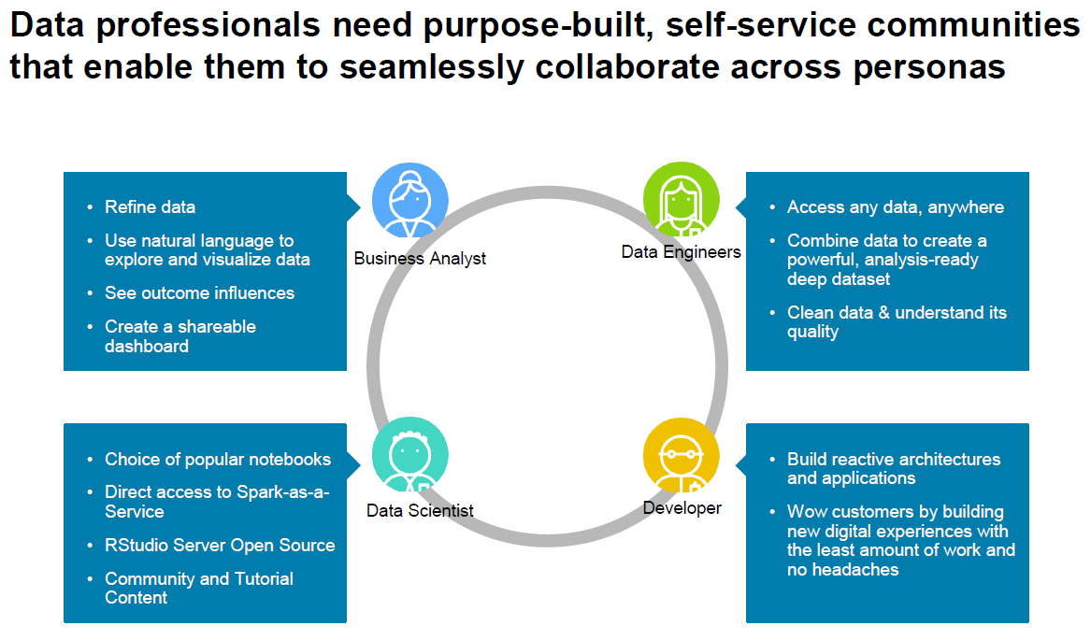

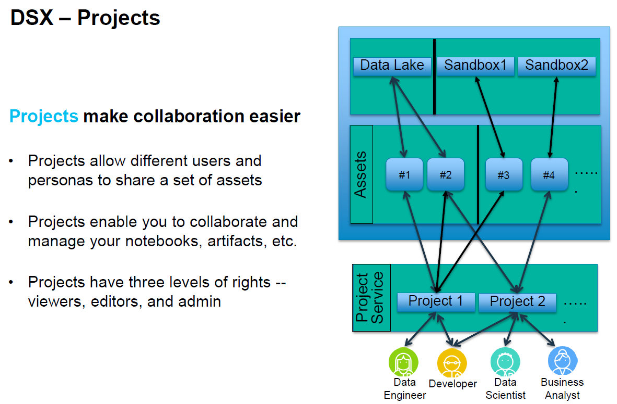

**Projects** make collaboration easier by:

* Allowing different users and personas to share a set of assets
* Enabling users to collaborate and manage their notebooks, artifacts, plus more
* Providing three levels of rights: Viewers, Editors, and Admins

| Action |
| --- |
| **2. Create New Project**   * Navigate to **https://datascience.ibm.com** * Login to DSX * On the top right side, click **Create New and select project**      * Type the Project Name **Customer Churn,** add a meaningful description:     Define Storage:   * Select **Object IBM Cloud Storage** * Click Add * Choose “Lite” plan then “Create” * Verify your options then “Confirm”   Define Compute Engine:   * Under “Select Spark Service” click on “Add” * Choose “Lite” plan then “Create” * Verify your options then “Confirm”      * Click **Create**     You now have a **Project** that is empty. You can use the tabs along the top to **add assets** to your project such as Connections, Notebooks, Data Assets, etc. You can also **add collaborators** to the Project. |

|  |
| --- |
| **3. Create Notebook**   * Click **Assets,** then **Add Notebooks**      * Choose **From URL** from the tab, give the notebook a name and meaningful description:      * In a separate browser window navigate to:   [Predicting Customer Churn with Watson Data Platform](https://github.com/team-wolfpack/Predicting-Customer-Churn-with-Watson-Data-Platform)  (https://github.com/team-wolfpack/Predicting-Customer-Churn-with-Watson-Data-Platform)   * Click on Notebooks, right click on **CustomerChurn-PySpark.ipynb** then choose **Copy link address**. Go back to the **DSX New Notebook** page.   Paste URL into **Notebook URL** text box then choose **Create Notebook**:    You should now see:    **Lesson 2 Continued in [Customer Churn – PySpark] Notebook** |

# Lesson 3: Machine Learning Flows

|  |  |
| --- | --- |
| Purpose: | This lesson introduces Machine Learning Flows in DSX. Flows provide a graphical approach to machine learning like that of SPSS Modeler. |
|  |  |
| Tasks: | Tasks you will complete in this lab exercise include:   * Create Machine Learning Flow * Import Data * Leverage Flows’ Palette to Orchestrate Customer Churn Machine Learning Pipeline * Evaluate Customer Churn Model |

## Lesson 3: Workflow Overview

## Lesson 3: Instructions

| Action |
| --- |
| **1. Load Data from Local File**   * In a separate browser navigate to: [Customer Churn Data](https://github.com/team-wolfpack/Predicting-Customer-Churn-with-Watson-Data-Platform/tree/master/Data):   https://github.com/team-wolfpack/Predicting-Customer-Churn-with-Watson-Data-Platform/tree/master/Data   * Download **customer_churn_data.zip** file, unzip and place customer_churn.csv in a folder on your computer. * Go back to the Customer Churn project and then click on the Data icon at the top right of the screen:   A new panel will be presented with Files highlighted. Click on browse, navigate to the customer_churn.csv file and select it. You should now see that the file has been imported into the project:    Navigate back to “Assets” and see the new “Data Asset”:    **2. Create Machine Learning Flow**   * Navigate to CustomerChurn project page * Click on “**New machine learning flow**”      * Choose “**Create flow**” on the top menu. Give the flow a meaningful name and description. For “Runtime” choose “**IBM SPSS Modeler**”:      * Click on “Create Flow” |
| **3. Add Data Asset**  You should now see an empty workspace.   * On the top left click on the “Palette” icon, and on the top right click on the “**Find and Add Data**” icon.     The palette represents the set of tools available for use with DSX flows. The menu of the right should look familiar.   * Let’s start by dragging and dropping the “**customer_churn.csv**” file onto the workspace.   **3. Add & Configure Type Object**   * From the palette, expand “**Field Operations**”, then drag and drop “**Type**” onto the workspace and to the right of “customer_churn.csv. Connect the two objects:      * Double click on “Type”, click on “**Configure Types**” then “**Add Columns**” * Add all the columns except for “ID”.      * Click on “Select Fields for Type” back arrow * For the “CHURN” column, change its Role to that of “**Target.”** Leave the default for the remaining columns:        * Click “OK”, then “Save” to exit.   **4. Add & Configure Model Object**   * From the palette, expand the “**Modeling**” branch then drag “**C&R Tree**” onto the workspace to the right of “Type.” * Connect the two then double click on “C&R Tree” to edit its properties. * The C&R Tree object should now say “CHURN”. Double click on this object. * Click on “FIELDS”, Target should be set to “CHURN”      * Click on “Add Columns.” Recall from the notebook exercise you were asked to jot down the top 5 fields that were identified as the greatest influencers. Choose those columns as inputs to the decision tree model. Click “OK” to return to the workspace: * Click on “Select Fields for CHURN” back arrow then “Save.” * Your palette should resemble this: |

**5. Run Flow to Create Nugget**

* Run the flow by clicking on the “Run” icon at the top of the workspace.

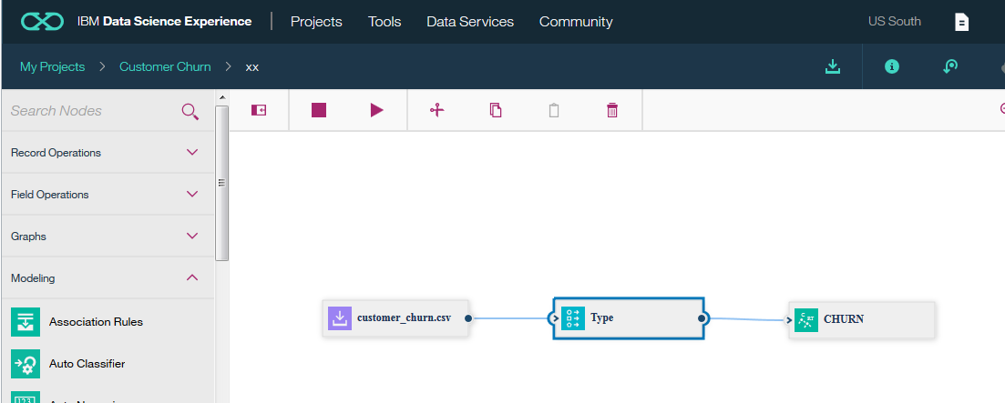

You should see a new forth object on the workspace, this is called a nugget.

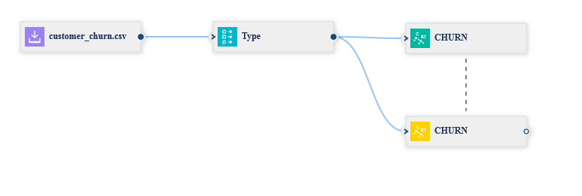

* From the palette add an “**Analysis**” object to the workspace, you will find it under the “Outputs” drop down. Also, from the “**Graphs**” drop down add a “**Distribution**” object to the workspace. Connect the nugget to each of them:

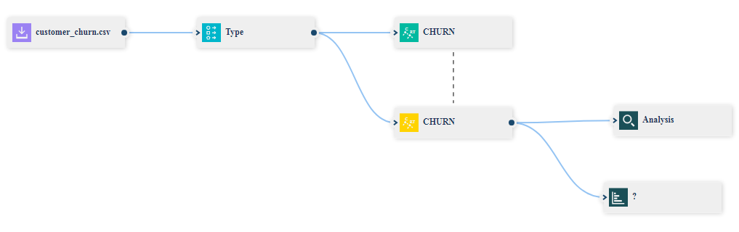

**6. Add & Configure Analysis Object – Measure Model Performance**

* Double click on “**Analysis**” and check off the four checkboxes, leave the rest as default:

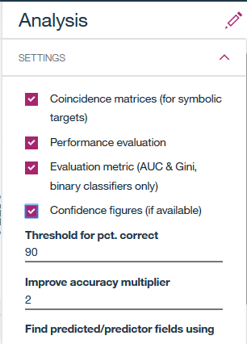

* Click “OK” to return to the workspace.
* Double click on “Plot” and configure it as depicted below:

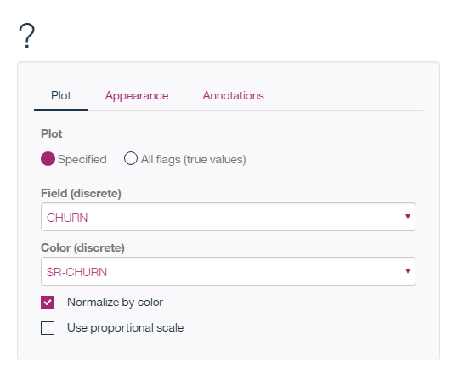

* Click on “Save” to return to the workspace.
* Run the flow again.
* On the right side of the workspace click on the “**Outputs and Versions**” icon to see the resulting analysis:

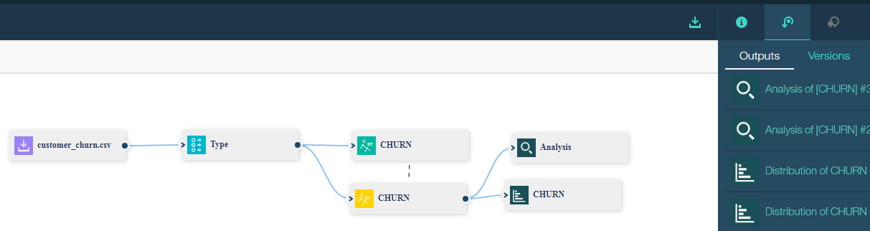

* Explore the results

**7. Add Second Modeling Technique to Flow**

* To the palette repeat the process for “**Random Trees**” that you did for “C&R Trees.” Your resulting workspace should look like the following:

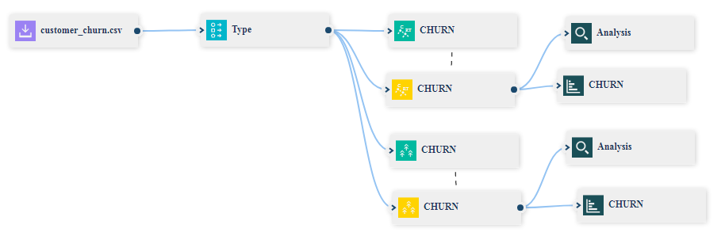

* Explore the results.

**End of Lesson 3**

# Lesson 4: Watson Machine Learning

|  |  |
| --- | --- |
| Purpose: | This lab introduces Watson Machine Learning in DSX. Watson Machine Learning makes the task of machine learning easy with as little as a few clicks of the mouse. |
|  |  |
| Tasks: | Tasks you will complete in this lab exercise include:   * Creation of requisite services to support Watson Machine Learning * Creation of Watson Machine Learning Models * Model Performance Evaluation * Deployment and Prediction of Model |

## Lesson 4: Workflow Overview

## Lesson 4: Instructions

| Action |
| --- |
| **1. Create Machine Learning Service**   * Navigate to Customer Churn project page * At the top click on the “**Settings**” icon: |
| Scroll to the middle of the page and click on “Add service” then choose “Machine Learning”:     * On the Machine Learning page make sure that the tab is set to “New”, for the plan choose “Lite”: |

* Click on “**Create**”
* At the confirmation page you can give your service a meaningful name:

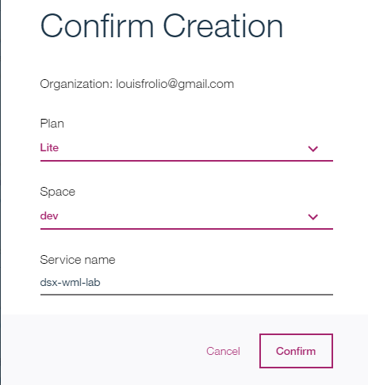

* Click “Confirm” to create Watson Machine Learning Service.

**2. Create Machine Learning Model**

* In the Project click on “**Assets**” at the top of the window.
* In the middle of the page you will see “**Models**”, click on “New model”:

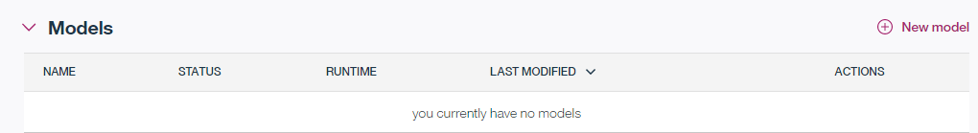

* In the “New model” window give your model a meaningful name and description, you should also see the machine learning service you just created. Click on “**Manual**” then “**Create**”:

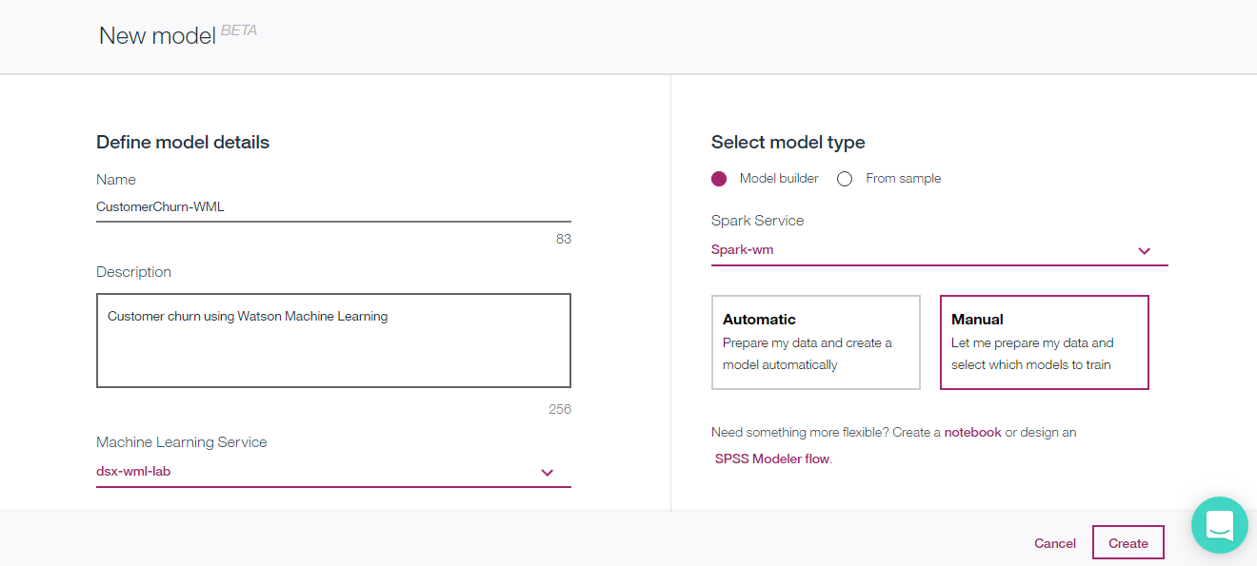

* When complete you will be prompted for a data asset, choose “customer_churn.csv”, then click “Next.”

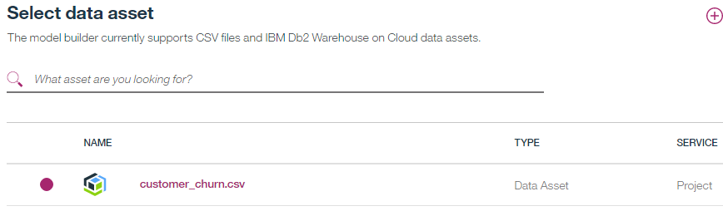

**3. Choose Modeling Technique**

* At the “**Select a Technique**” screen select “**CHURN**” as the “**Column value to predict**”, and for the feature columns choose 5 -9 identified in the Jupyter notebook lab. Also, make sure “**Binary Classification**” is highlighted:

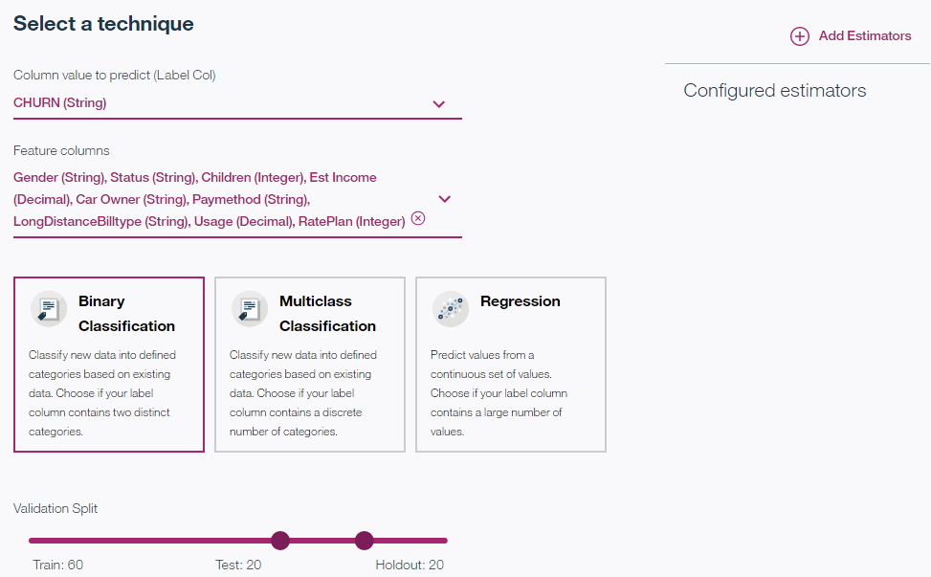

**4. Add Estimators**

* In the upper right-hand corner of the screen you will see “**Add Estimators**”, click on the icon. In the “Select estimator(s)” screen choose **Decision Tree Classifier**, and **Random Forest Classifier**:

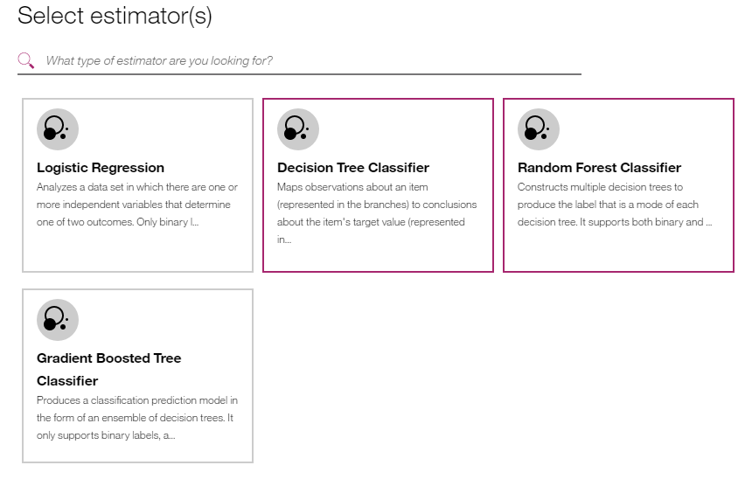

* Click “Add”:

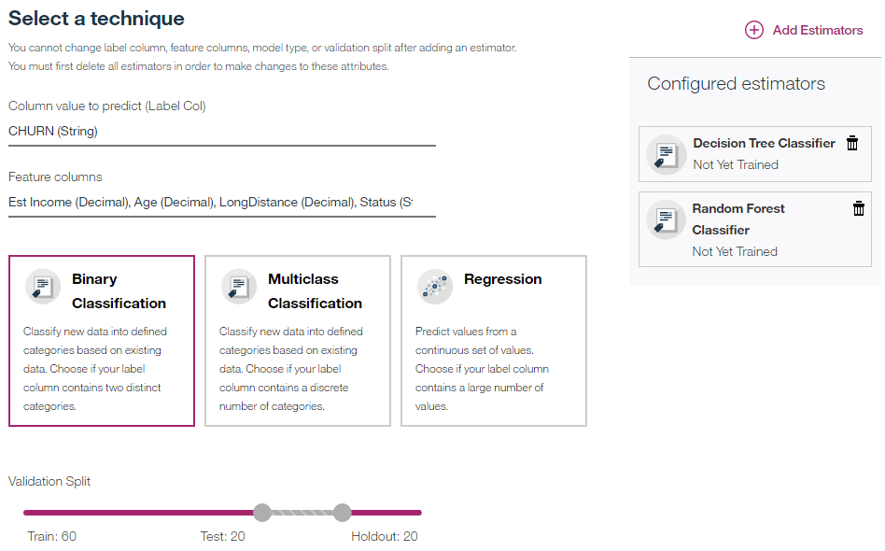

* Click “Next” to train models. This will take 1-2 minutes with the data set we are using:

**5. Evaluate Models**

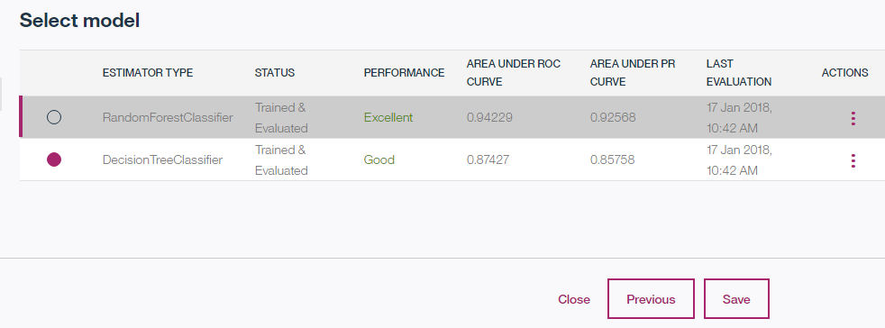

**6. Save & Deploy Model**

* Pick which model you want to keep then click “Save:”

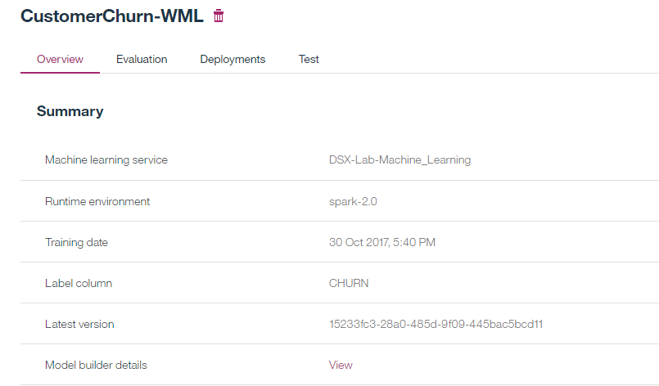

The overview page provides useful information about the model. This includes the ability to deploy and predict with the model.

* Click on “Deployments” then “**Add Deployment**”:

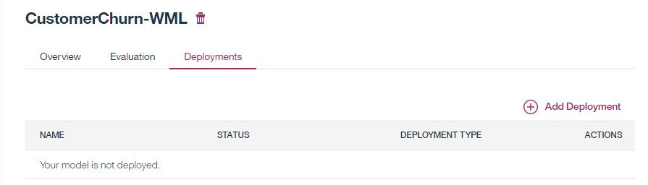

* For deployment type choose “**Batch Prediction**” then give the deployment a useful name:

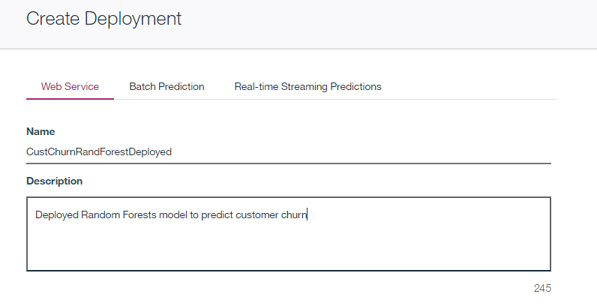

* Click “Save”

**7. Predict with Model**

* Choose newly created deployed model:

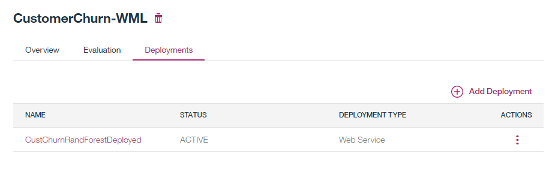

* Click on “**Test**” to test the model.

The input features will be pre-populated, but you can change them to see different outcomes. Just be sure that the values you add are valid as per the data set. **See “Summary Statistics**” from the Jupyter notebook exercise:

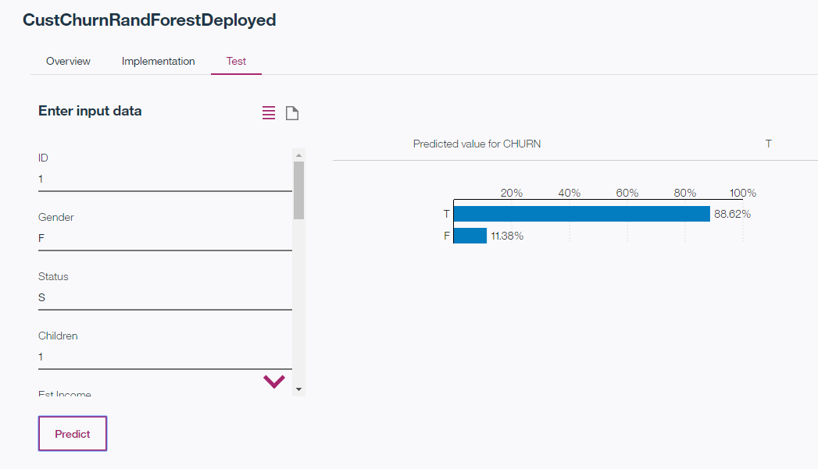

**End of Lesson 4**

**End of Hands-on Workshop**

**Thank You**